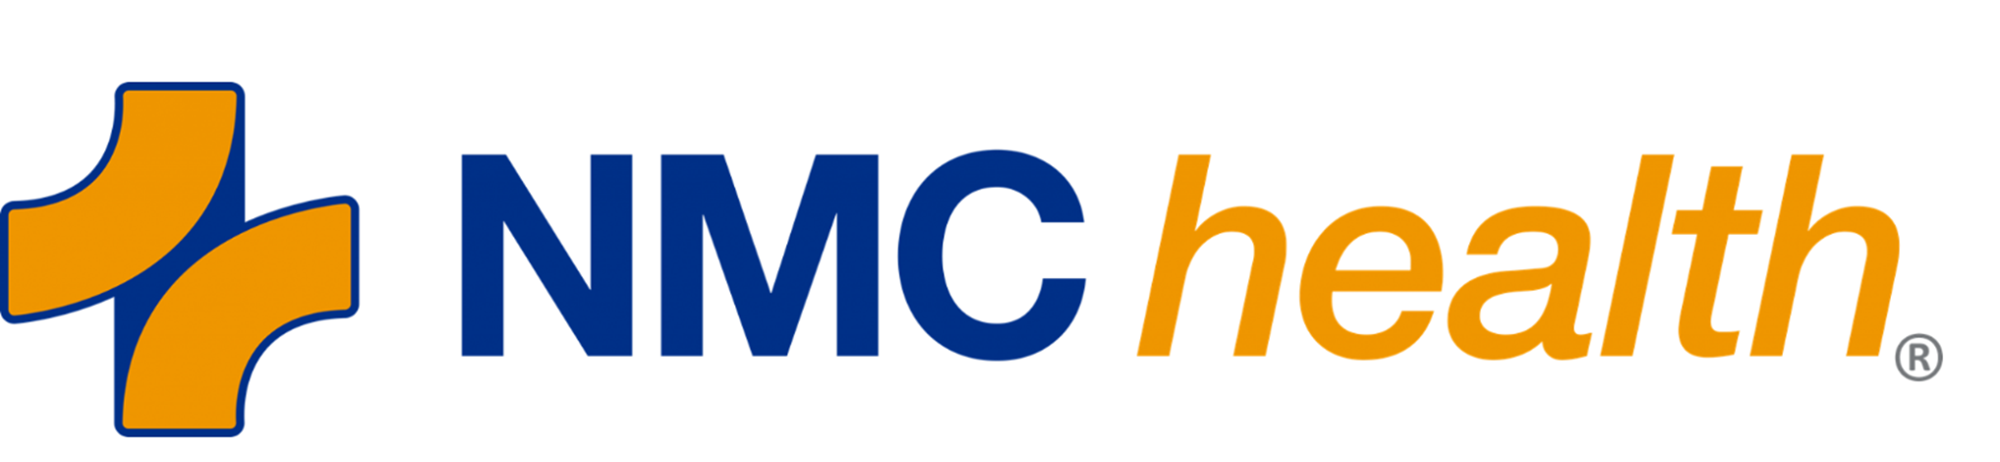
VOLUNTEER APPLICATION

PERSONAL INFORMATION
Full Name
Street Address
City, State, Zip
Email | Best Telephone

VOLUNTEER EXPERIENCE
Organization or Agency | Start/End Dates | Description of Service
WORK EXPERIENCE
Company | Start/End Dates | Position/Job

SPECIAL SKILLS OR HOBBIES
List any special skills or hobbies that you enjoy (clerical, mechanical, music, food, nursing, counseling, foreign language, etc.)

PLEASE READ THE FOLLOWING BEFORE SIGNING THIS APPLICATION
I certify the information in this application is current to the best of my knowledge. I understand falsification of fact or significant omission is grounds for disqualification from further consideration, or for dismissal as a NMC Health volunteer. I authorize NMC Health to contact former employers, organizations, agencies, schools, references to verify my information.
I agree to abide by the rules, regulations, policies and procedures of NMC Health. I understand that either NMC Health or I may terminate the volunteer relationship at any time with or without cause and with or without notice.
I understand that I may be required to submit and successfully complete a medical examination and tests at the expense of NMC Health as a condition of volunteering.
I understand that NMC Health is a smoke-free environment and volunteers are not permitted to smoke in and outside the facility.
I understand that NMC Health will conduct a pre-volunteer criminal background check. I hereby acknowledge this and authorize all parties and organizations to provide this information to NMC Health requests relative to the background check process.

Attendance at Volunteer Base Camp One and Two (volunteer orientation and training) does not obligate you to accept a volunteer assignment. Following training, you will be interviewed to discuss your options for volunteer service. Thank you for considering a volunteer opportunity with NMC Health!

Authorized Signature of Applicant | Date
Volunteer Services Staff Signature

